**CLOUD WATCH**

AWS CloudWatch is a powerful monitoring and observability service provided by Amazon Web Services. It enables you to gain insights into the performance, health, and operational aspects of your AWS resources and applications. CloudWatch collects and tracks metrics, collects and monitors log files, and sets alarms to alert you on certain conditions.

**Cloud watch performs:-**

- Monitoring

- Real life metrics

- Alarms

- Log insights

- Custom metrics

- Cost optimization

- Autoscaling

**Task to be done:-**

We’ll set up CloudWatch alarms for critical metrics of an application, define appropriate threshold conditions, and configure notification actions.

1.Create an EC2 instance

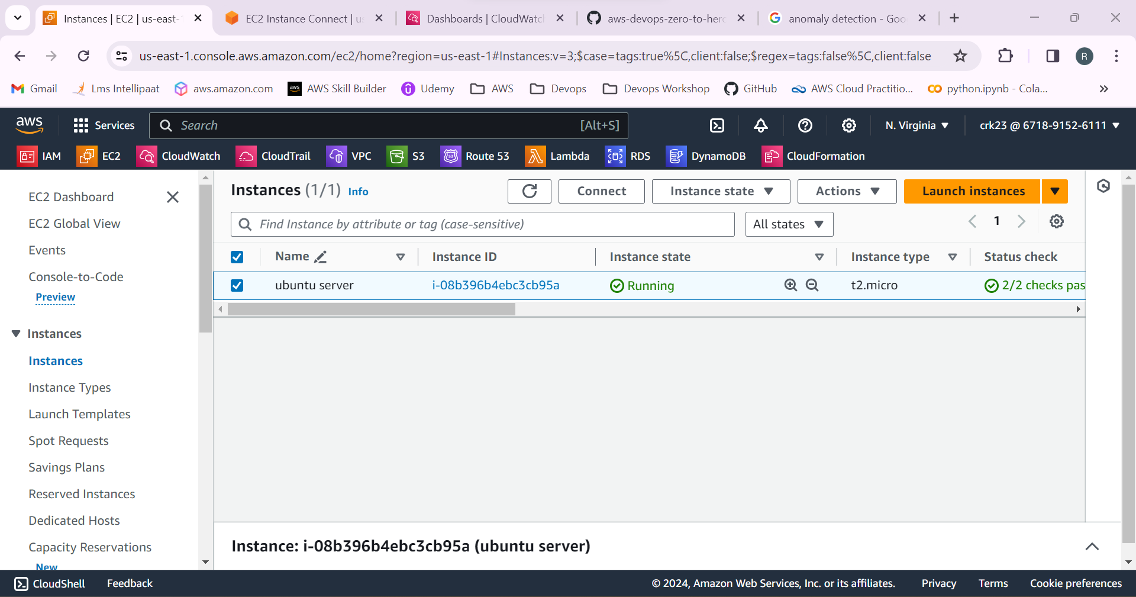

2.Use the **top** command to get the real-time information about the system performance including CPU, memory and process usage.

Everything is working normal.

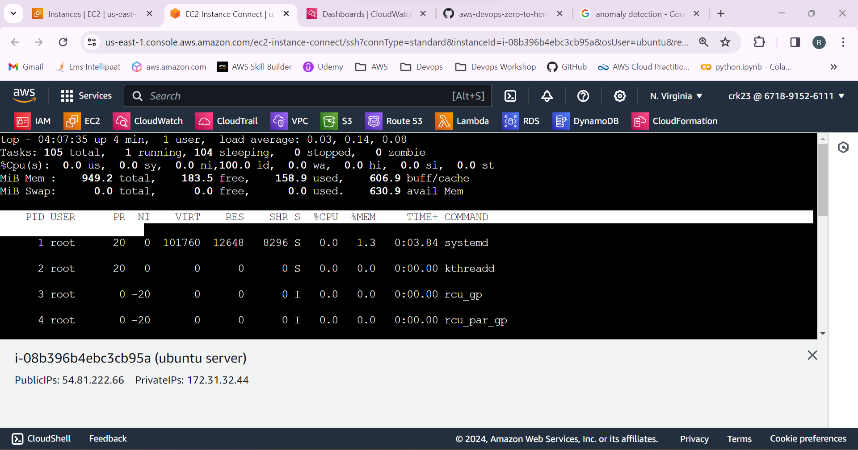

3.Select Cloudwatch from AWS services.

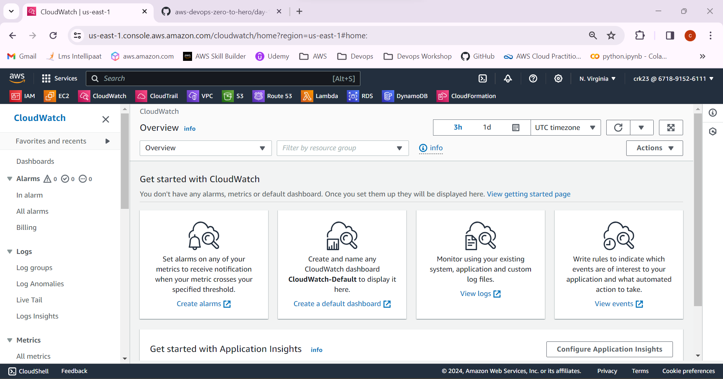

4.Select the metrics > EC2 > select the EC2 instance created.

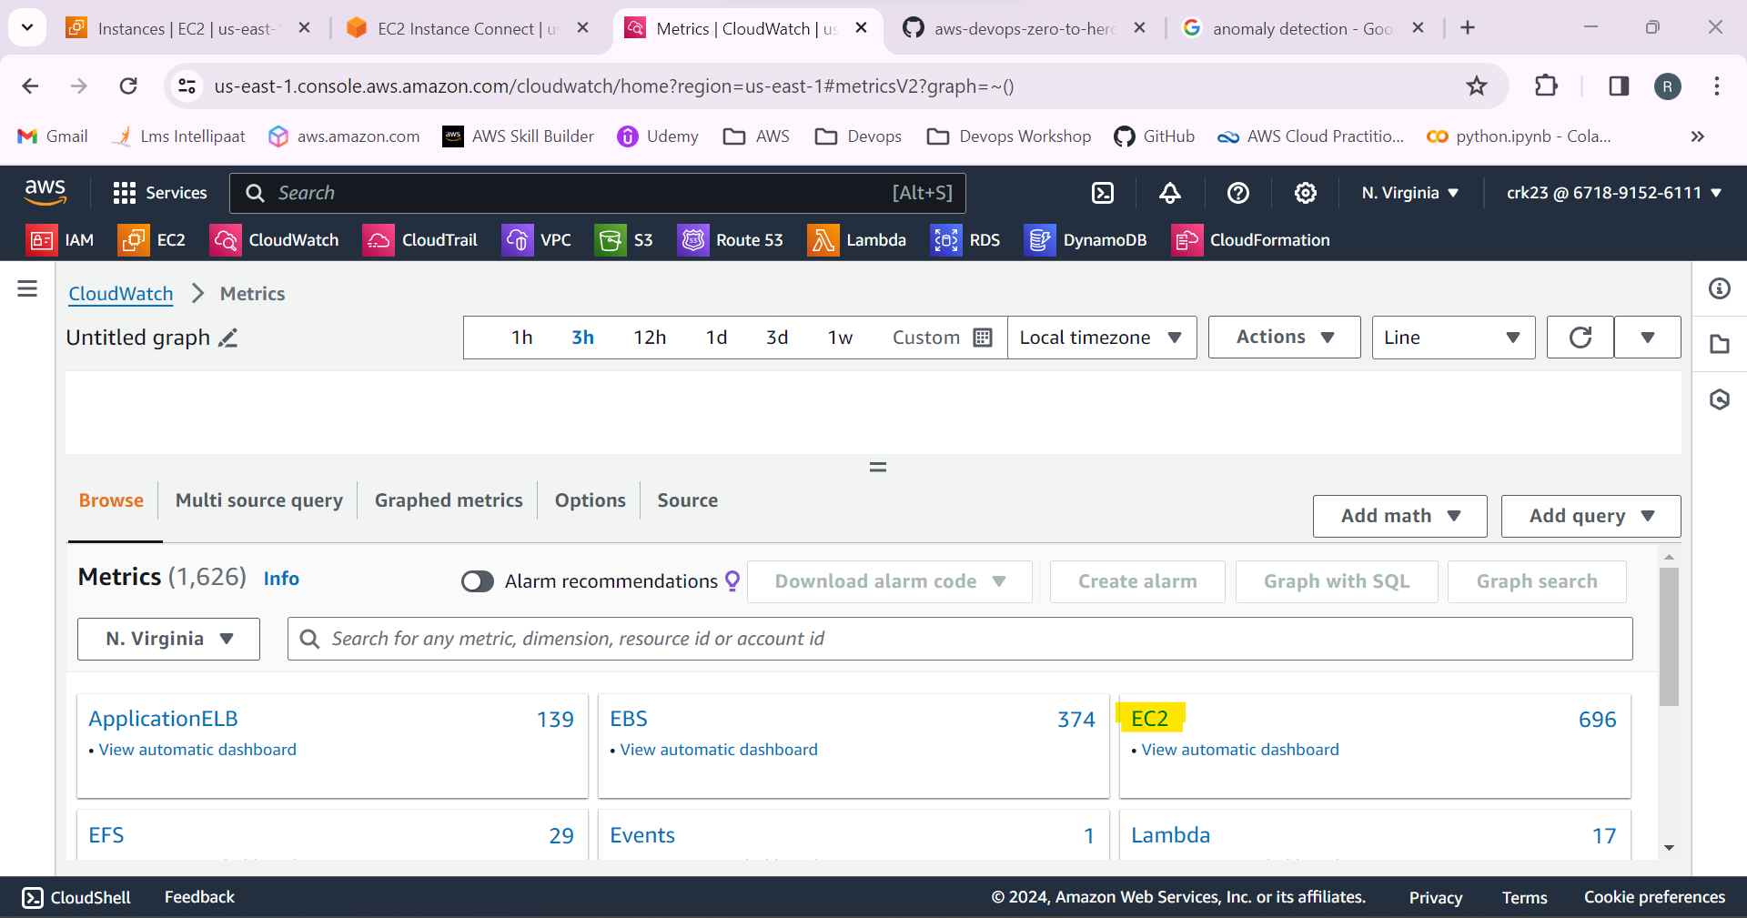

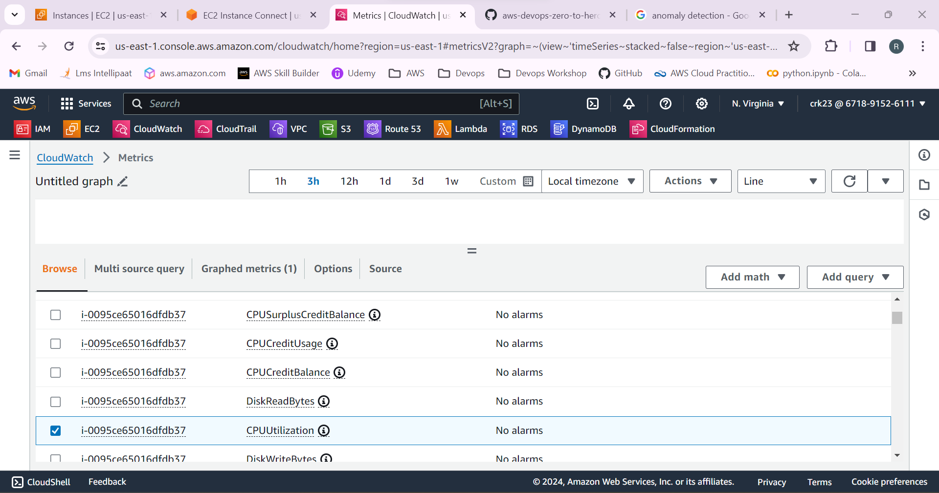

5.Select the EC2 instance > Monitoring > Manage detailed monitoring.

This will enable cloud watch to monitor every 1 minute. By default it is 5 minutes.

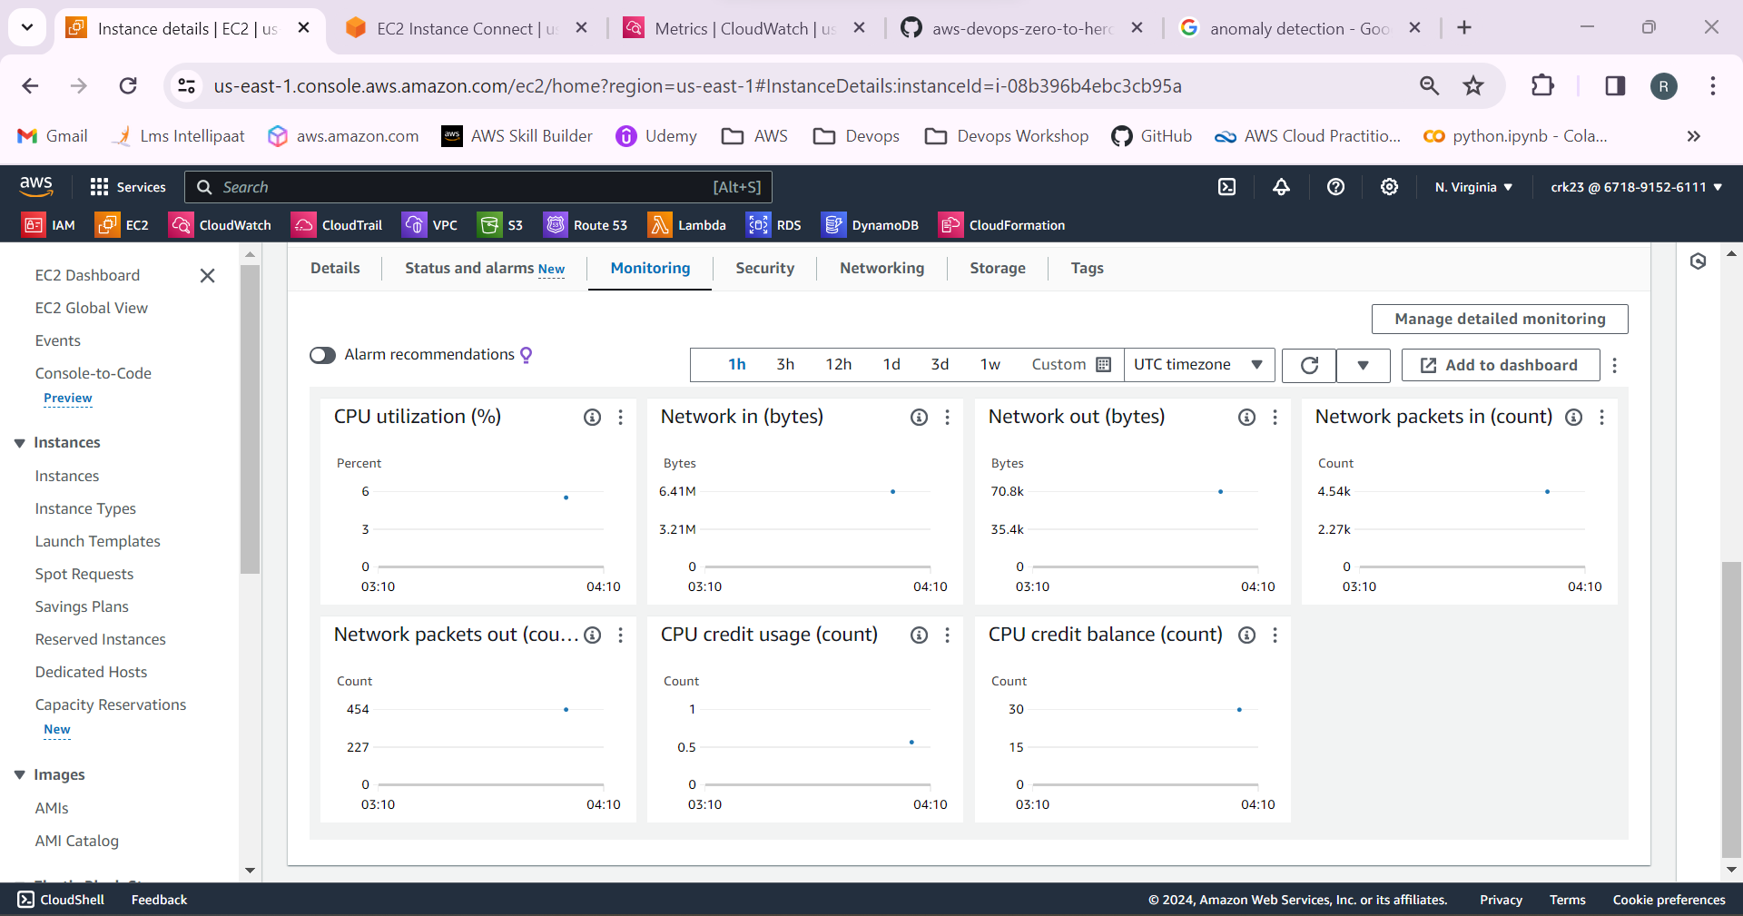

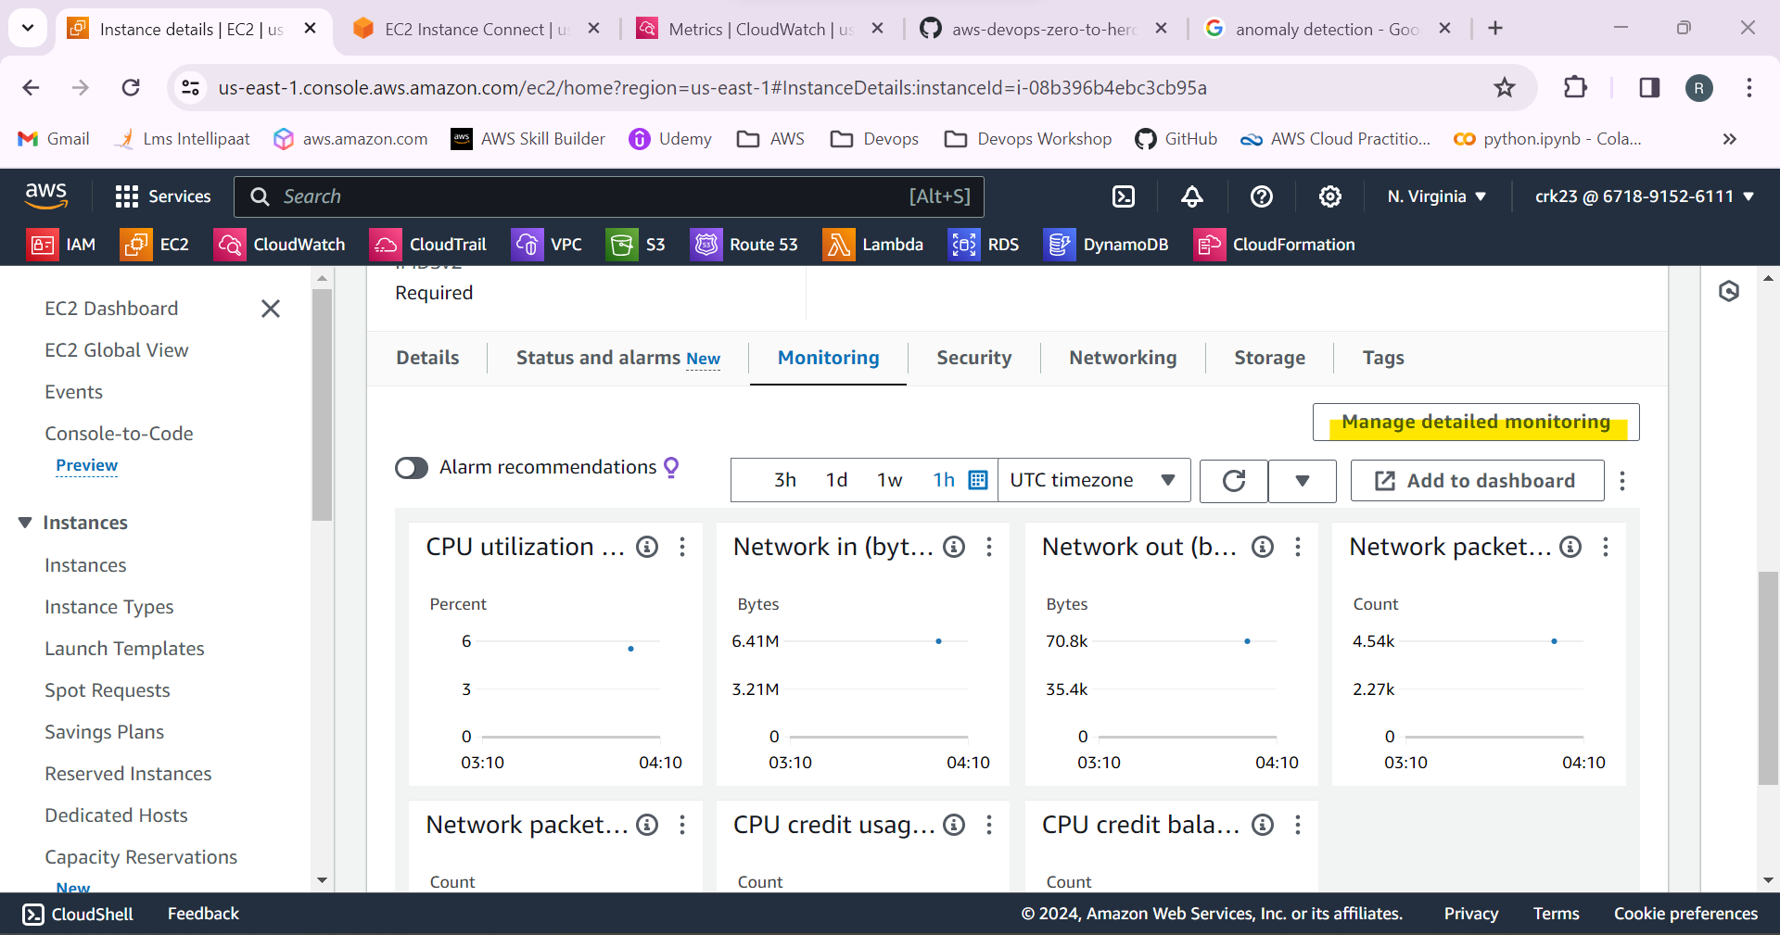

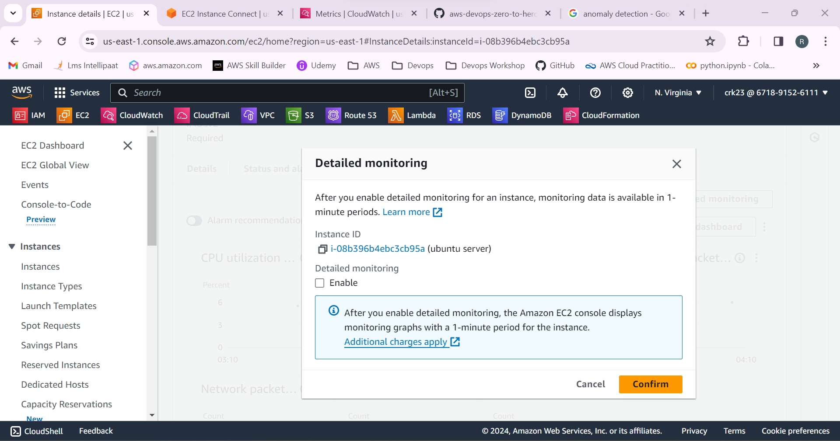

6.Login to the instance and check whether the python is installed or not. Python3 is installed.

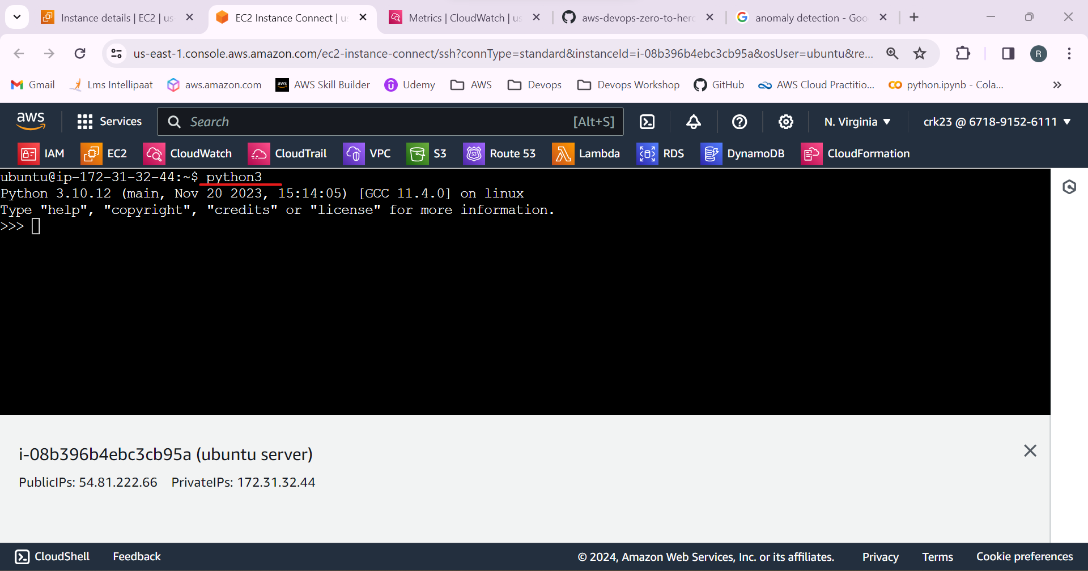

7. Created a python file and used an python program to increase the CPU utilization. We can also use the stress commands to increase the CPU, memory and network.

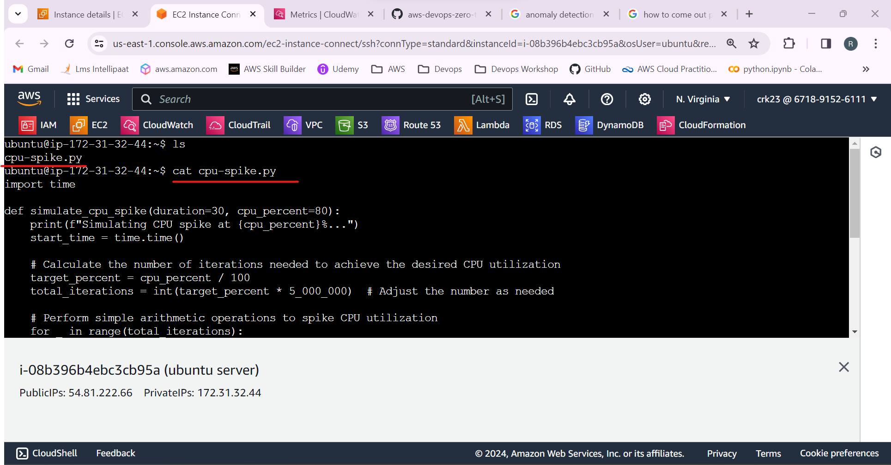

8.Use the command **python3 “filename”**  to start the python program.

Program started simulating the CPU utilization at 80% .

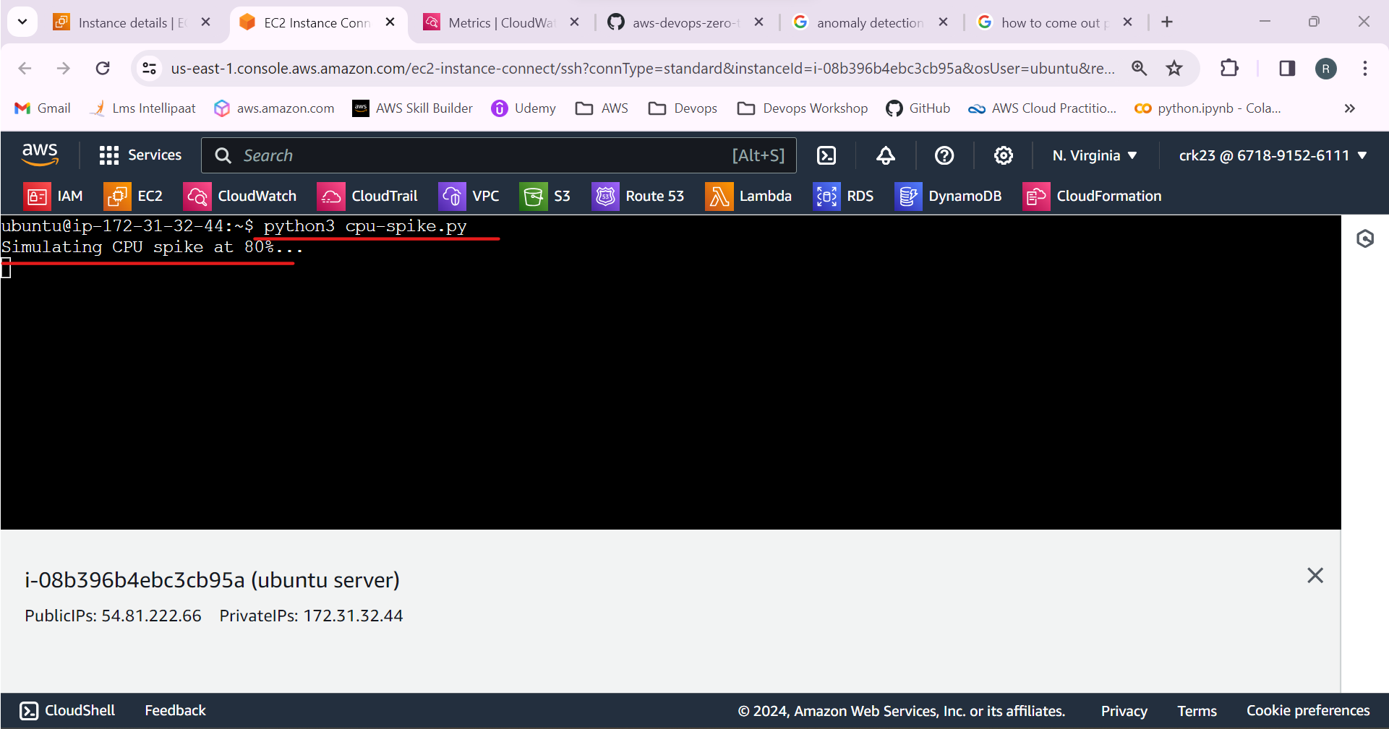

9.Check the monitoring tab in the EC2 instance to see the spike of percent at which time.

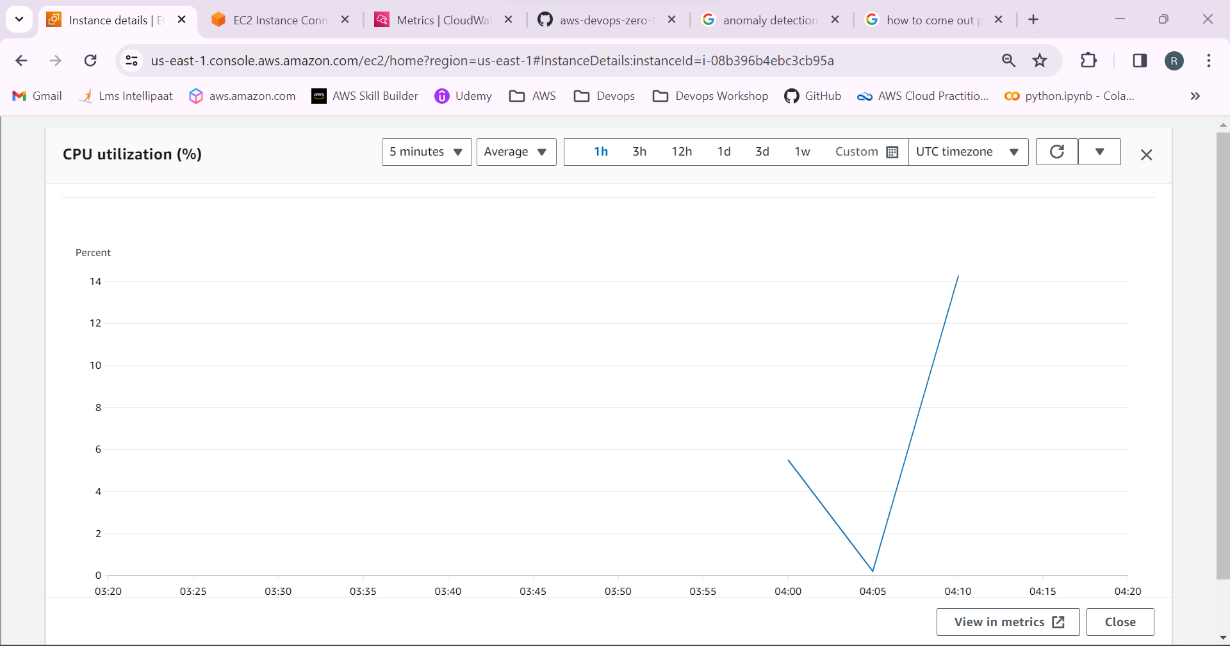

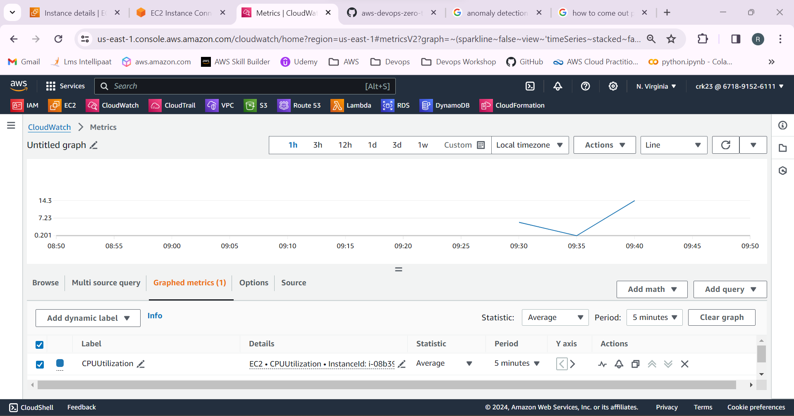

After the programs stops running the CPU utilization come backs to normal.

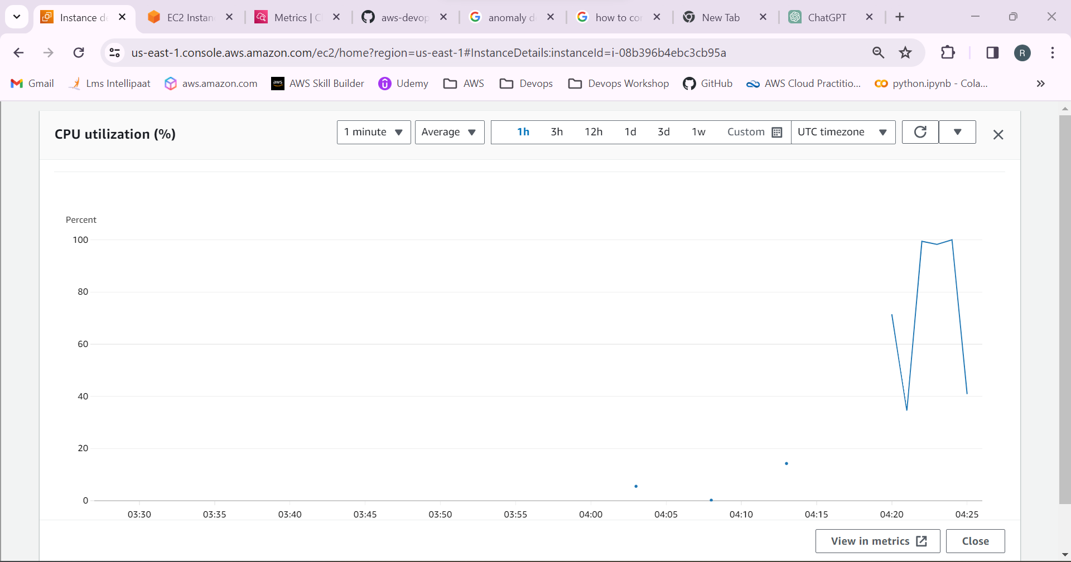

10.Select the alarm and create an alarm to send a notification email when CPU utilization crosses 60%.

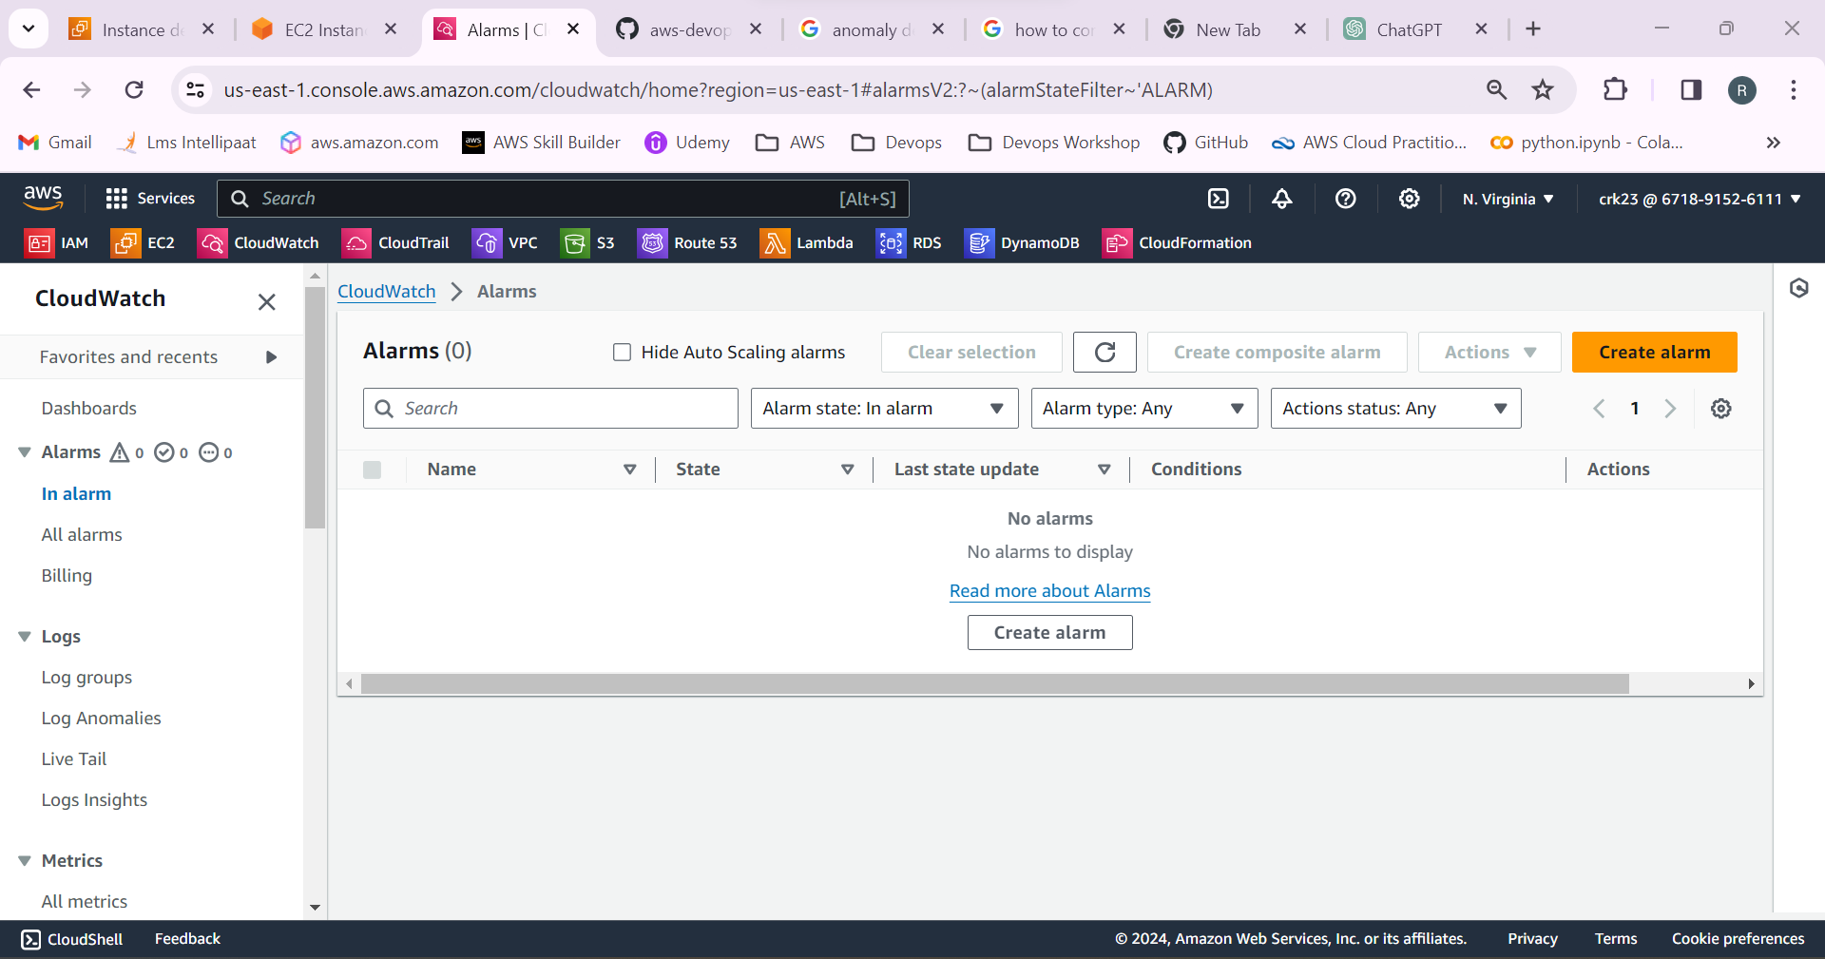

-Select the metric as line of the EC2 instance.

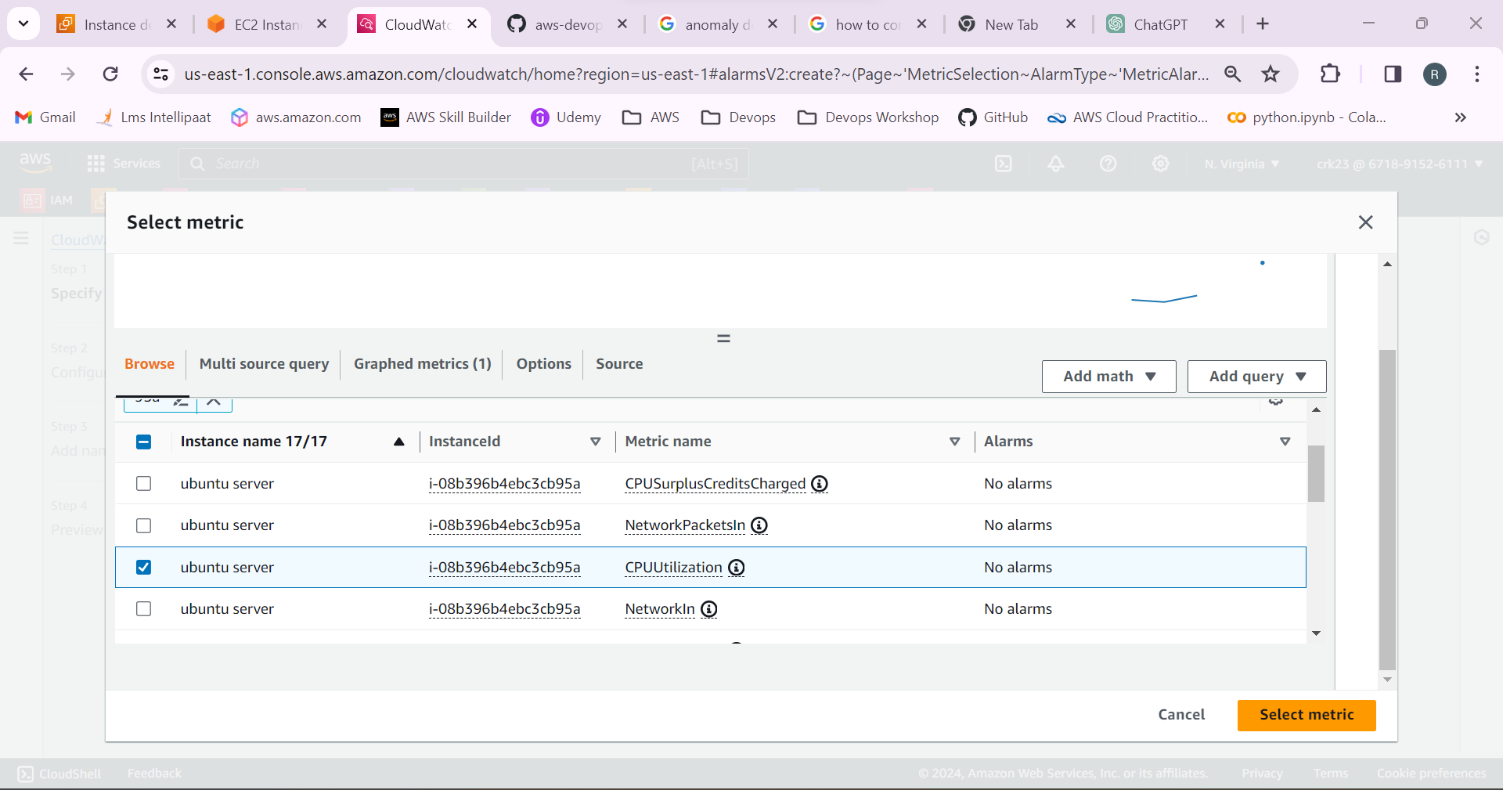

- Give metric name and statistics as maximum and period as 1 minute.

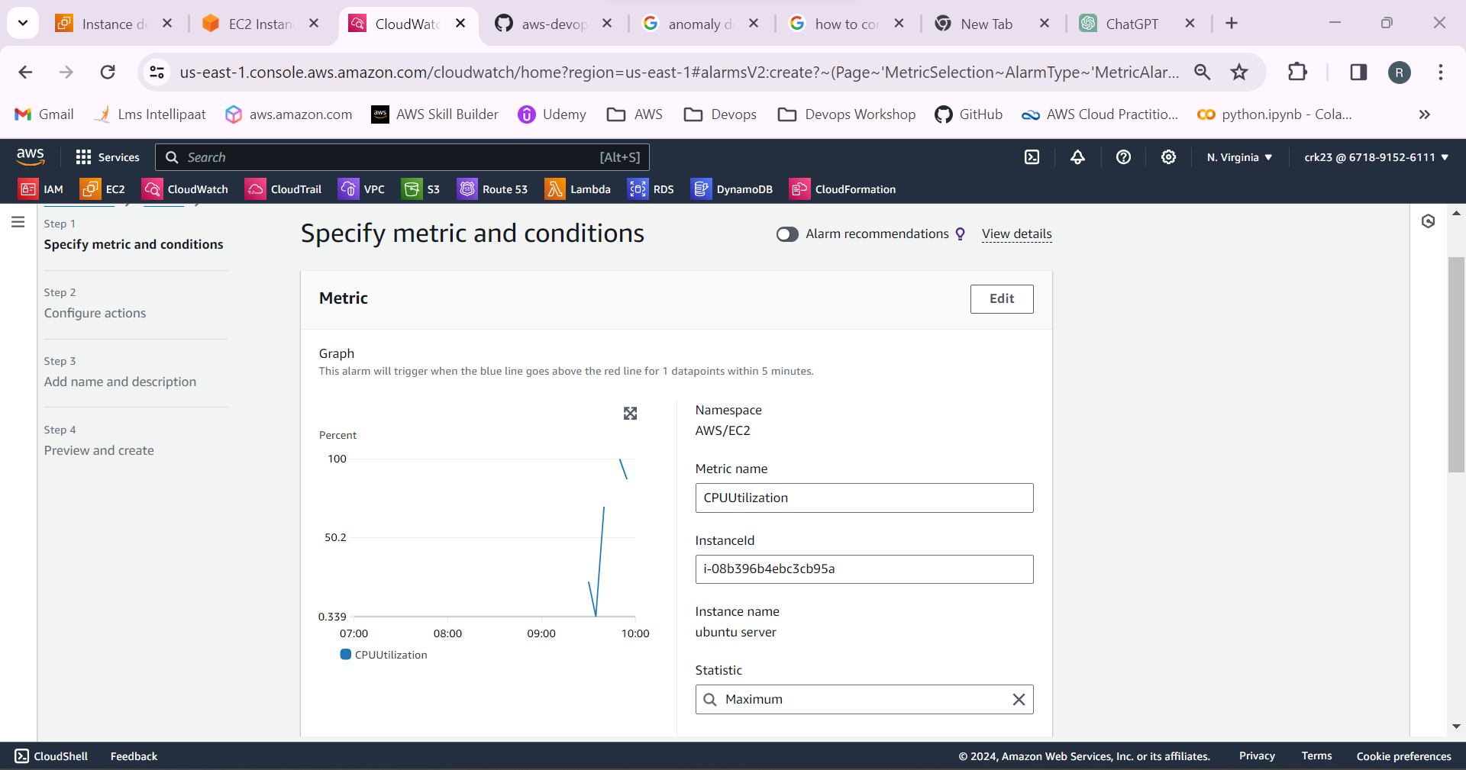

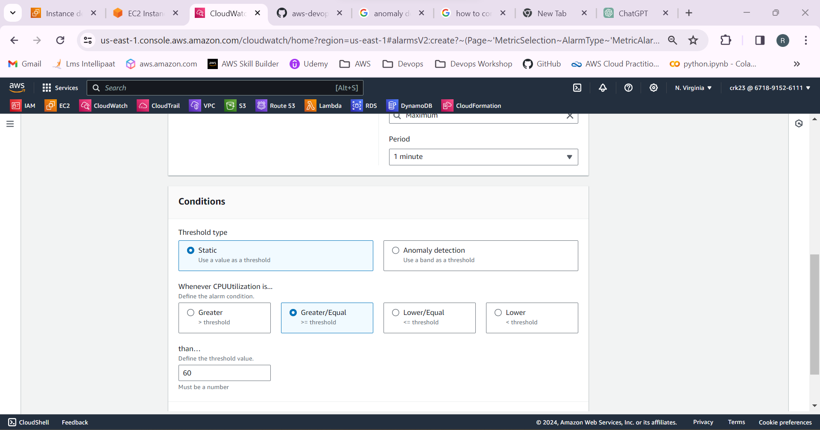

-Create an SNS topic and give the email to which the notification has to be sent.

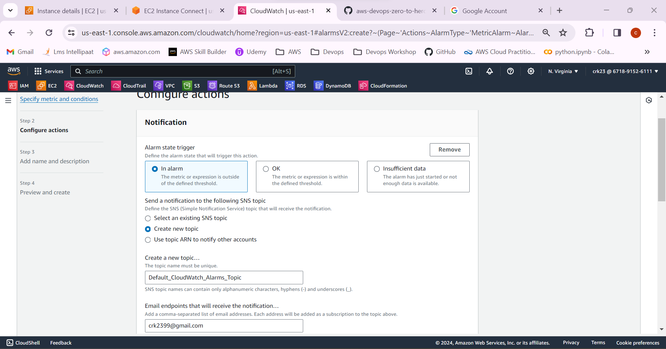

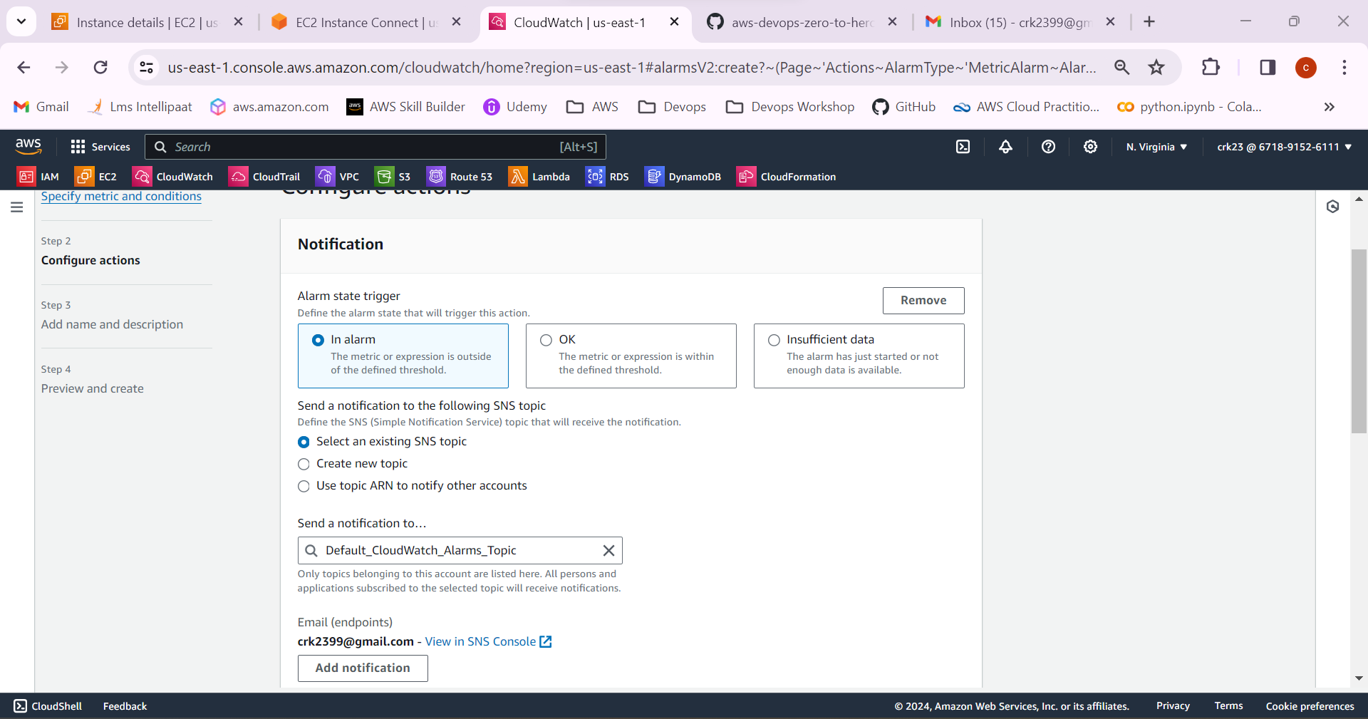

-Give the alarm name and message to be included in the email.

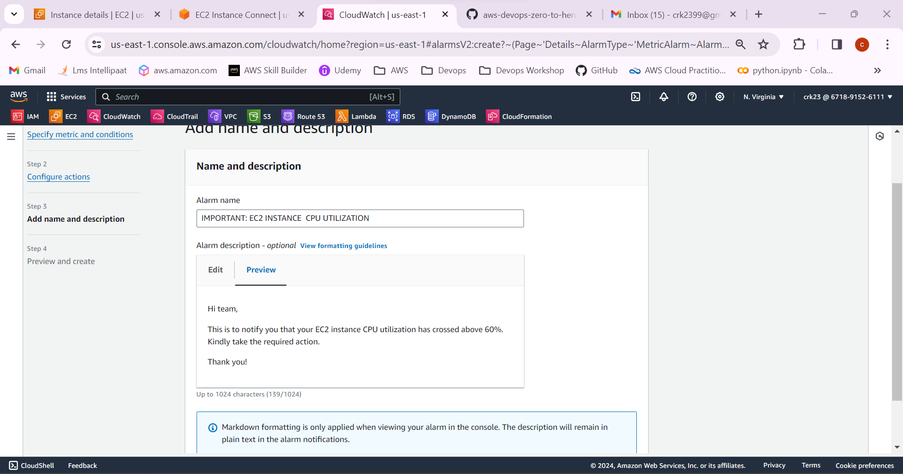

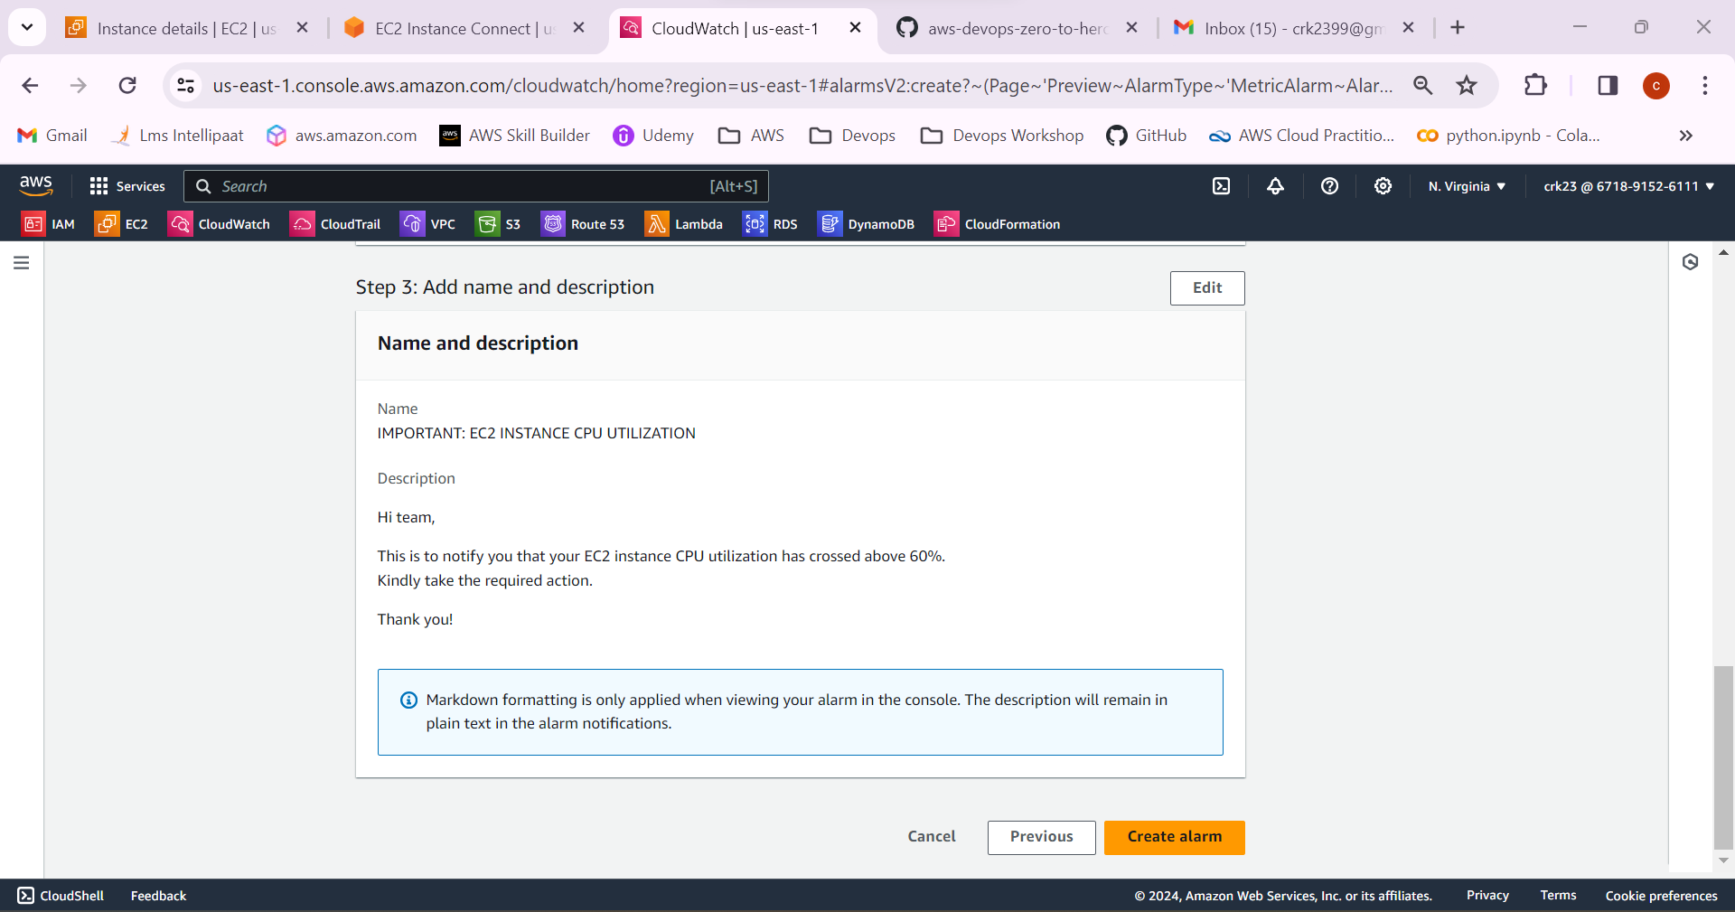

-We will receive a confirmation email to confirm subscription.

Confirm the subscription.

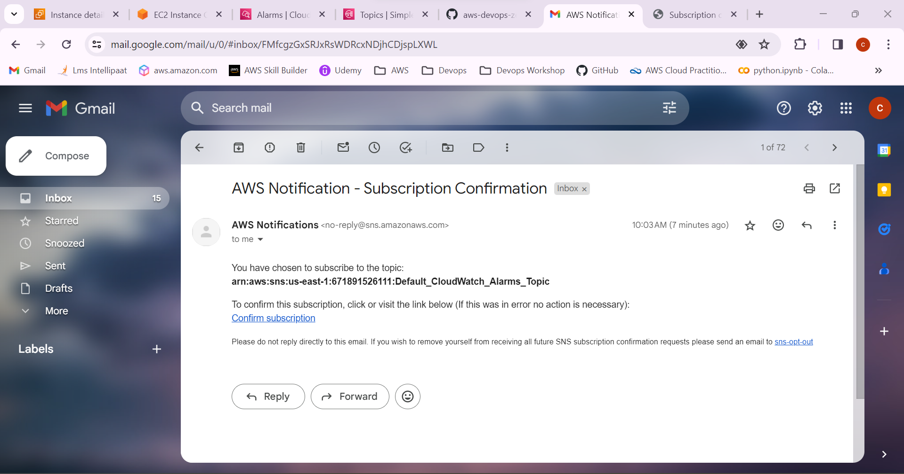

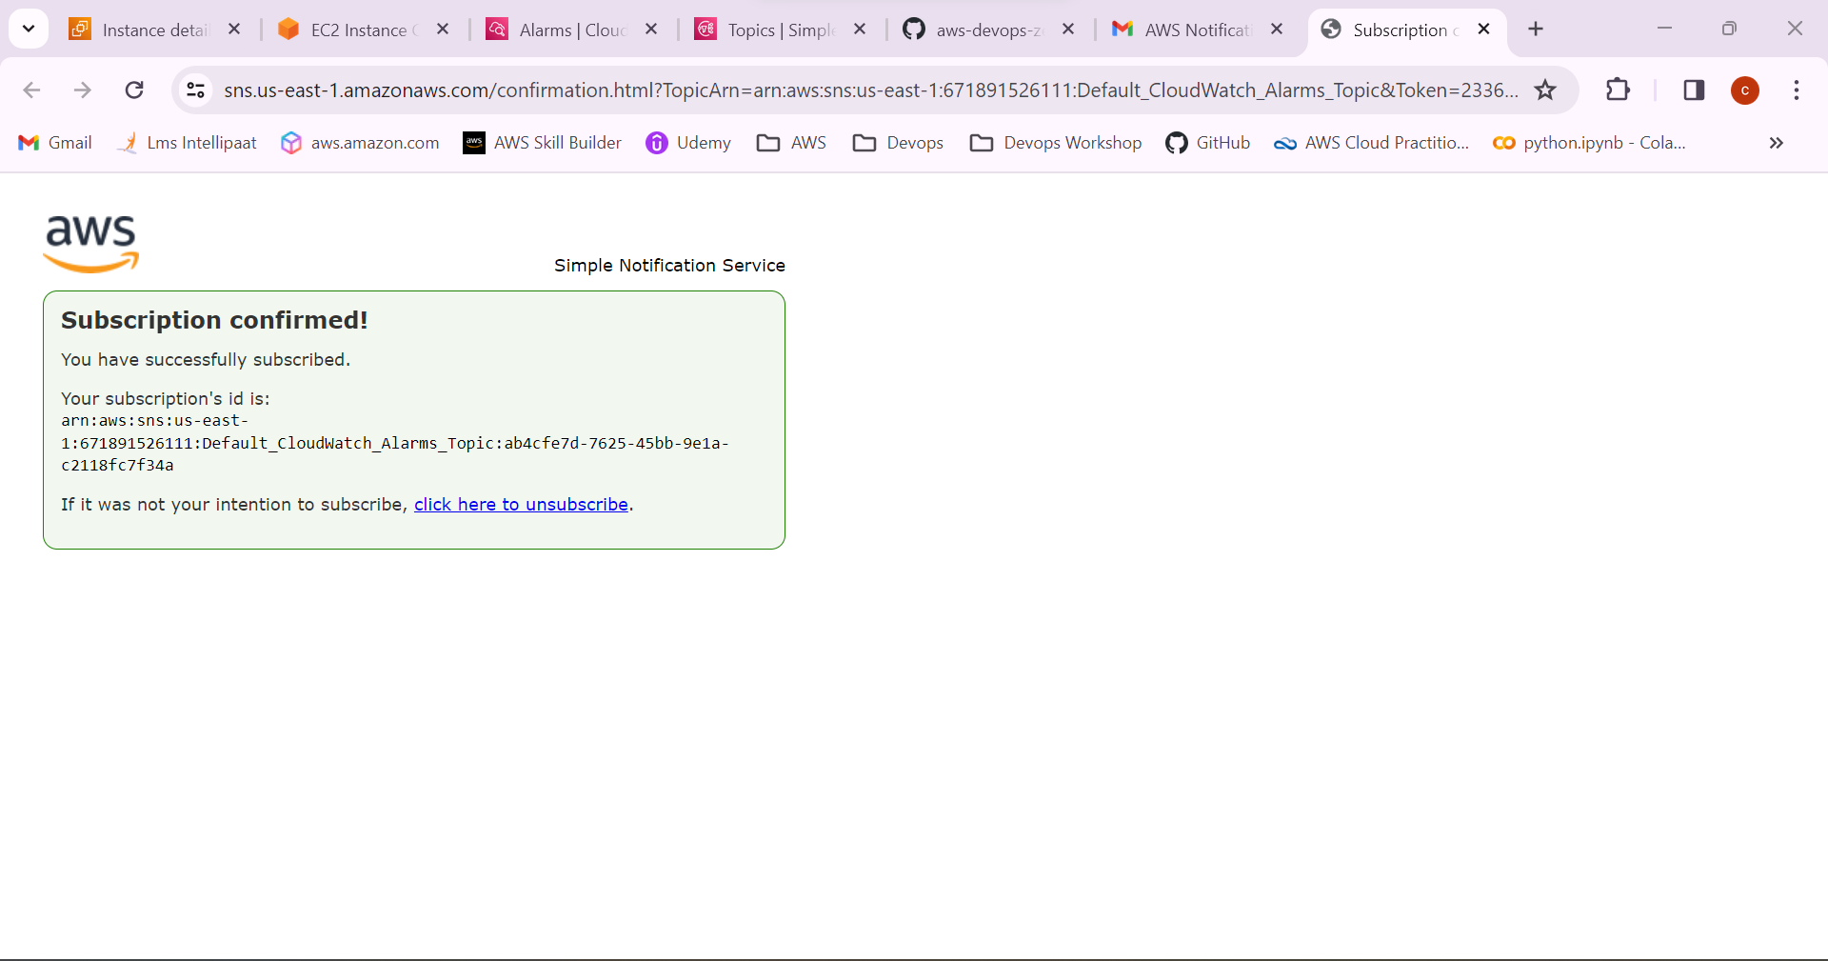

11.Alarm has been created.

It will be in **All alarms** state when the email subscription.

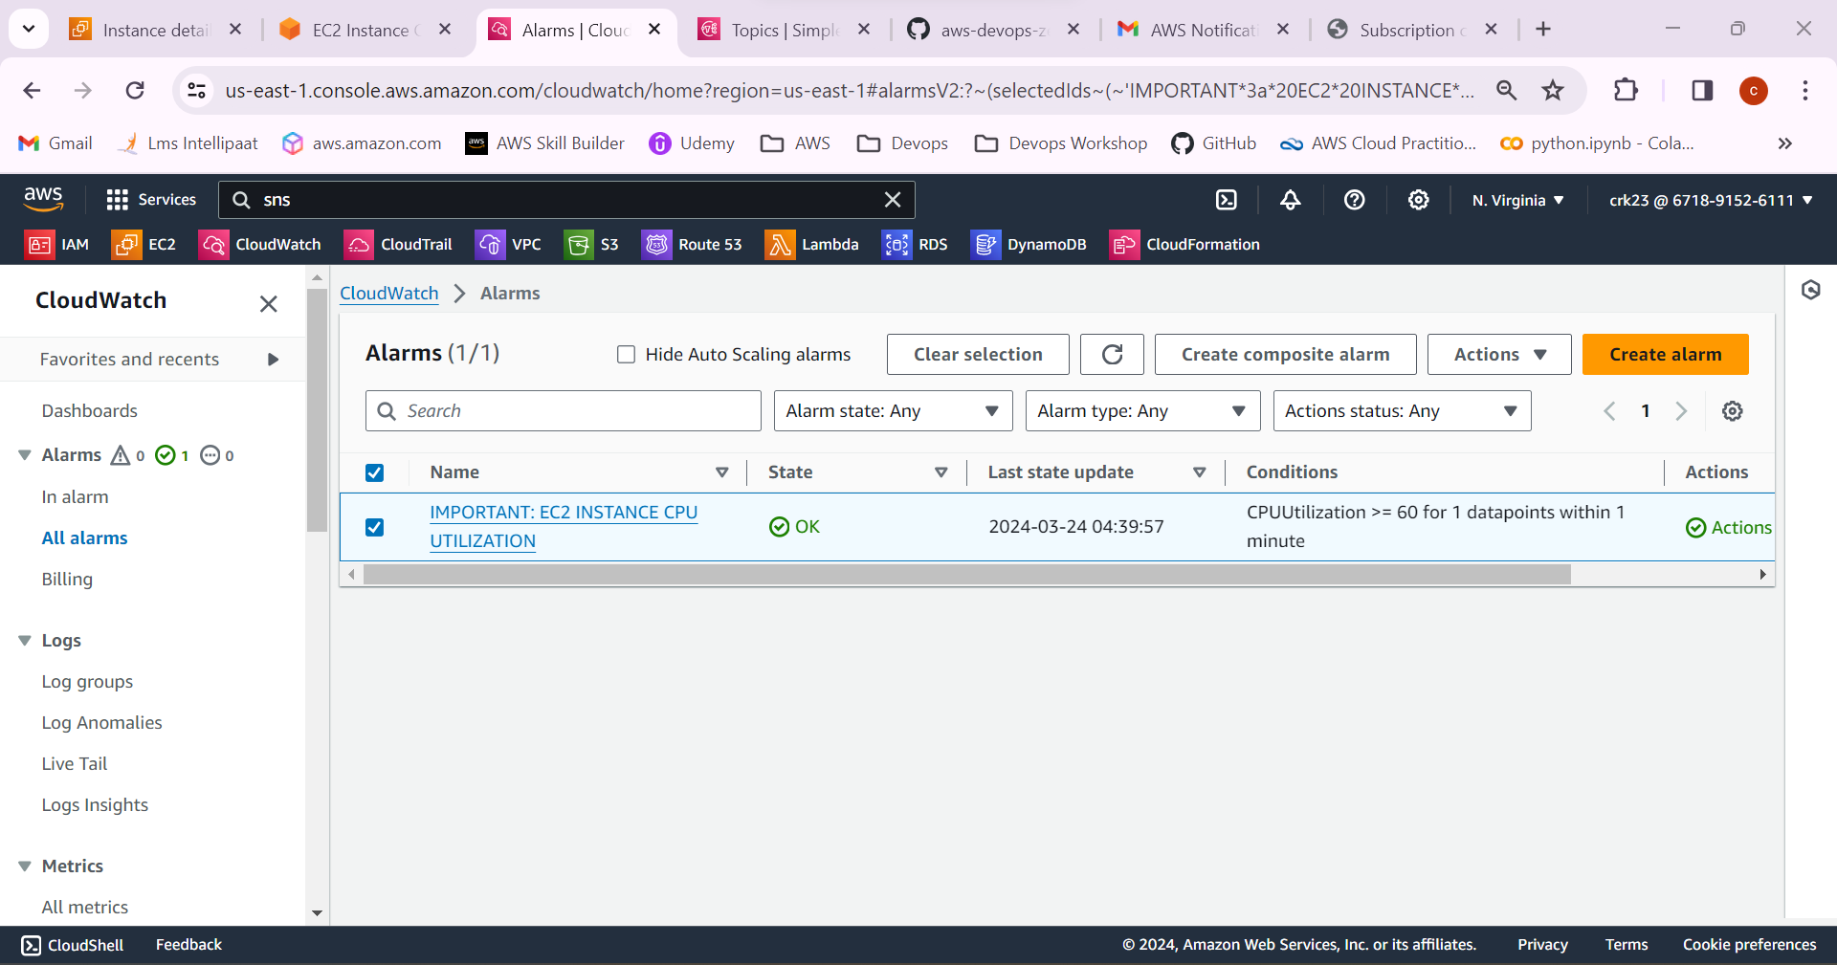

12.Go the EC2 instance and start the python program to run which will stress the CPU utilization.

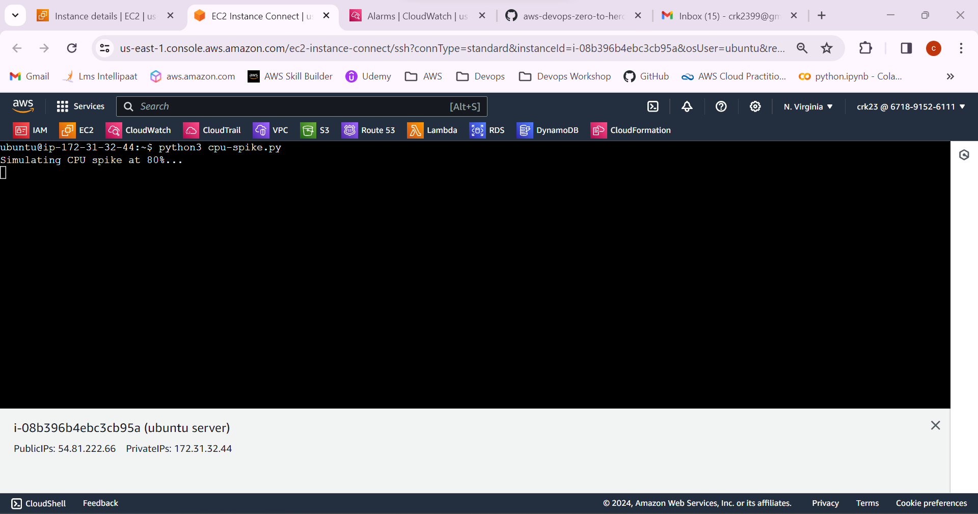

-It will take some time to reach the threshold level mentioned.

When the level crossed cloud watch will trigger the SNS topic to send the email.

-CPU utilization has now crossed the 60%.

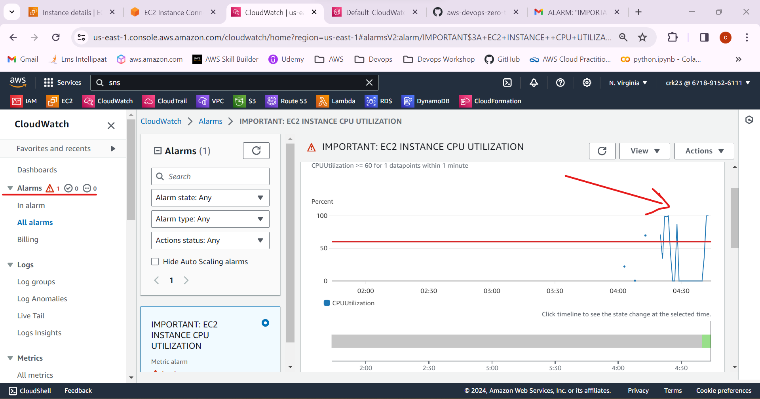

13.Notification has been received in the email.

